### **AI-powered Nutrition Analyzer for Fitness Enthusiasts**

### Team Leader **:** E.Santhiya

Team Member : P.Shalini, S.Sneha, M.Sridharan.

Faculty Mentor Name : Sweetline Sonia M

**Build Python Code**

**Importing Libraries**

* The first step is usually importing the libraries that will be needed in the program.

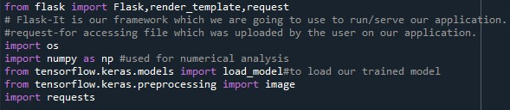

* Importing the flask module into the project is mandatory.
* An object of the Flask class is our WSGI application.
* Flask constructor takes the name of the current module (__name__) as an argument Pickle library to load the model file.